17.124: a) In hot weather, the moment of inertia I and the length d in Eq. (13.39) will both increase by the same factor, and so the period will be longer and the clock will run slow (lose time). Similarly, the clock will run fast (gain time) in cold weather. (An ideal pendulum is a special case of physical pendulum.) b) 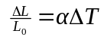 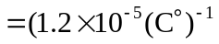 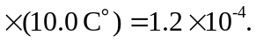 c) See Problem 13.97; to avoid possible confusion, denote the pendulum period by For this problem,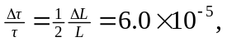 so in one day the clock will gain so

